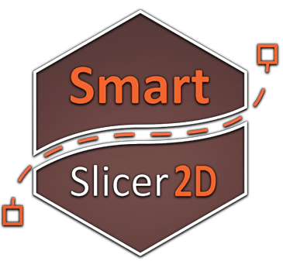
Updated: 2021 / 01 / 19
Current Asset Version: 2021.1.1
Latest Documentation: Link
Roadmap: Link
Discord Support: Link

User Manual Sections
Component Reference  Description of each component of Slicer 2D |  | Soon - How to Start?
Soon - Event Handling |  | Soon - Custom Controller
Soon - Slicing Objects |  | Soon - Center of Slice

- Slicer2D Components
  - Components
  - Component Reference
  - Bonus Components

- Slicer2D Main Scripting API
This API is used to interact with existing game objects that got Slicer2D component attached
  - Static Methods
  - Static Methods Reference
  - Slice2D & Slice Result

      - Slicer2D Events Handling
        - AddEvent
        - AddResultEvent
        - Anchors - AddResultEvent

- Slicer2D Low Level Scripting API
This API is used to create your own custom slicer controllers and unique behaviour
  - Static Functions
  - Static Functions Reference

Math2D Scripting API | Polygon2D Scripting API | Vector2D Scripting API

Controller Features | Event Handling Sample Scripts

Forum Discussion
Contact: simonas@kuzmickas.lt

Slicer2D Components

Components
Slicer2D | Physics component for slicing sprites & meshes (Require Collider2D)
Slicer2DController | Mainly for mouse input which is used to slice or affect sliceable objects
Slicer2DParticles | Adding particles effect for sliceable game object
Slicer2DSound | Adding sound effect for sliceable game object
Slicer2DLinearController | Simplified version of Slicer2DController for linear mode slicing only
Slicer2DComplexController | Simplified version of Slicer2DController for complex mode slicing only

Bonus Components
Mesh2D | Creates a mesh from attached Collider2D
ColliderLineRenderer2D | Draw lines for the attached Collider2D
JointRenderer2D | Draws lines for the attached joint components

Component Reference
Slicer2D
appearance | 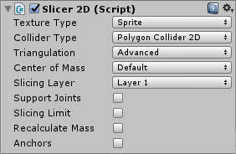
description | Physics component for Slicing sprites & meshes
information | Parameters:  - Texture Type  - Sprite  - Mesh  - None  - Slicing Layer  - 8 layers  - Slicing Limit  - Optionable (after 1-10 slices object won’t be sliceable)  - Recalcuate Mass

Slicer2DController
appearance | 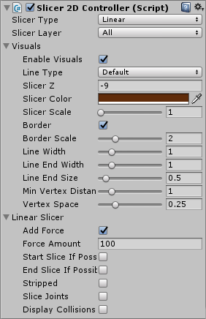
description | Mainly for mouse input which is used to slice or affect sliceable objects
information | Parameters:  - Slicer Type  - Linear  - Linear Cut  - Linear Tracked  - Complex  - Complex Cut  - Complex Tracked  - Complex Point  - Point  - Polygon  - Explode  - Explode By Point  - Creator  - Linear Trail  - Complex Trail  - Slicer Layer:  - All  - Selected (checkbox list for 8 layers)

Mesh2D
appearance | 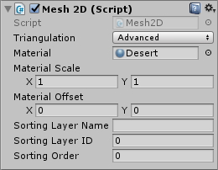
description | Creates a mesh from already attached Collider2D
information | Parameters:  - Triangulation  - Advanced  - Legacy  - Material

ColliderLineRenderer2D
appearance | 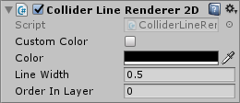
description | Draws lines for attached Collider2D
information | Parameters:  - Color  - Line Width  - Order in Layer
Slice2D & Slice Result
This object is used to return results and other additional information after slicing bodies

Slice2D
object fields | - Slice2D  - polygons List <Polygon2D>  - gameObjects List <GameObject>  - collisions List<Vector2D>  - slice List<Vector2D>  - slices List<List<Vector2D>>
description | Contain information about the slice.  Used in scripting Slicer2D API and events handling system.
Sample 1
Prints all information about the slice into console
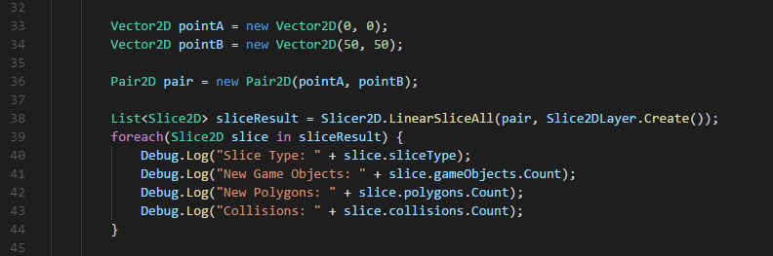
Sample 2
Uses event system to add Rigidbody2D component after slicing the GameObject
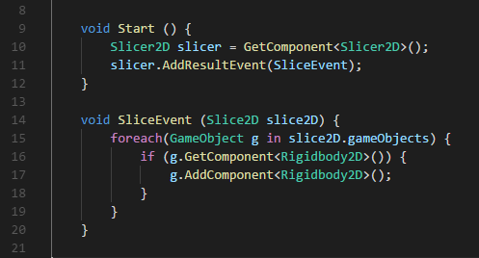

Slicer2D Main Scripting API
This API is used to interact with existing game objects that are having Slicer2D component attached

Static Methods
LinearSliceAll | Slice all objects linearly using a line by 2 given points
LinearCutSliceAll | Slice all objects linearly using a line by 2 given points & width
ComplexSliceAll | Slice all objects non-linearly by given points list
ComplexCutSliceAll | Slice all objects non-linearly by given points list & width
PointSliceAll | Slice all objects linearly by a point and given rotation
PolygonSliceAll | Slice a piece of area from a polygon - using polygon as a parameter
ExplodeByPointAll | Explode a polygon by a given point
ExplodeSliceAll | Explode all objects
GetList | Get List of Slicer2D components in the scene
GetListLayer | Get List of Slicer2D components with specific layer in the scene

Static Methods Reference
Static List <Slice2D> Slicer2D.LinearSliceAll ( Pair2D slice, Slice2DLayer layer = ALL)
returns | List of Slice2D objects list
description | Slice all GameObjects in the scene with Slicer2D component attached.  Slices linearly using a line by 2 given points
information | <not documented yet>

Static List <Slice2D> Slicer2D.LinearCutSliceAll ( LinearCut slice, Slice2DLayer layer = ALL)
returns | List of Slice2D objects list
description | Slice all GameObjects in the scene with Slicer2D component attached.  Slices linearly using a line by 2 given points & width
information | <not documented yet>

Static List <Slice2D> Slicer2D.PointSliceAll ( Vector2D position, Vector2D rotation)
returns | List of Slice2D objects
description | Slice all GameObjects in the scene with Slicer2D component attached.  Slice linearly by a point and given rotation
information | <not documented yet>

Static List <Slice2D> Slicer2D.ComplexSliceAll ( List<Vector2D> slice, Slice2DLayer layer = ALL)
returns | List of Slice2D objects list
description | Slice all GameObjects in the scene with Slicer2D component attached.  Slice an object non-linearly by given points list
information | <not documented yet>

Static List <Slice2D> Slicer2D.PolygonSliceAll ( Polygon2D polygon, Slice2DLayer layer = ALL)
returns | List of Slice2D objects list
description | Slice all GameObjects in the scene with Slicer2D component attached.  Slice a piece of area from a polygon - using polygon as a parameter
information | <not documented yet>

Static List <Slice2D> Slicer2D.ExplodingSliceAll ( Vector2D point, Slice2DLayer layer = ALL)
returns | List of Slice2D objects list
description | Explode all GameObjects in the scene with Slicer2D component attached.  Explode a polygon by a given point
information | <not documented yet>

Static List <Slice2D> Slicer2D.ExplodeSliceAll ( Slice2DLayer layer = ALL)
returns | List of Slice2D objects
description | Explode all GameObjects in the scene with Slicer2D component attached.  Explode all objects
information | <not documented yet>

Slicer2D Events Handling

Public Methods
AddEvent | Attach event script to sliceable object  triggered before slice
AddResultEvent | Attach event script to sliceable object  triggered after slice
AddAnchorEvent | Attach event script to sliceable object  triggered before slice  returns objects that were detached from anchors
AddAnchorResultEvent | Attach event script to sliceable object  triggered after slice  returns objects that were detached from anchors

Static Methods
AddGlobalEvent
AddGlobalResultEvent
AddGlobalAnchorEvent
AddGlobalAnchorResultEvent

AddEvent
description | This event is applied before new sliced objects are created.  If this event method  - Returns “false” - the slice will be canceled  - Returns “true” - the slice will be performed  Slice2D object contains fields:  - Polygons  - Slice Type  - Collisions  - Slice  - Slices
Sample 1
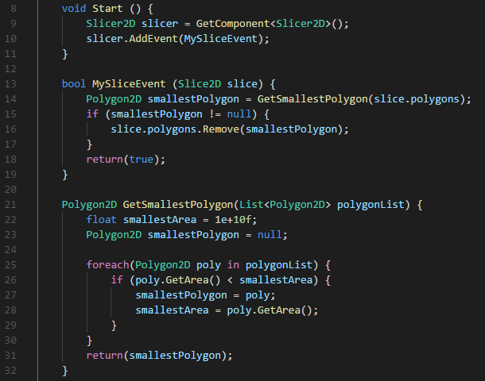
Removes smallest slice from result
Smallest new polygon won’t be created
Sample 2
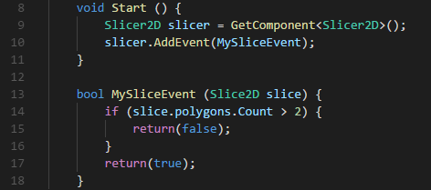
This sample canceles the slice if it creates more than 2 new objects

AddResultEvent
description | This event is applied after new sliced objects are created.  This event method cannot cancel slice.  Slice2D object contains fields:  - Game Objects  - Slice Type  - Polygons  - Collisions  - Slice  - Slices
Sample 1

This sample attaches a rigidbody for every new slice of the object

AddAnchorResultEvent

More Info: https://discord.gg/AktrfBe
description | This event is applied after new sliced objects are created.  This event method cannot cancel slice  This event returns all new game objects that were cut off from the original object..  Slice2D object contains fields:  - Game Objects  - Slice Type
Sample 1
(this was changed in recent updates, now this method is in Slicer2D component)

This sample destroy all objects that were sliced from the original game object

Slicer2D.API Low Level Scripting API
This API is used to create your own custom slicer controllers and unique behaviour

Functions
LinearSlice | Slice an object linearly using a line by 2 given points
LinearCutSlice | Slice an object linearly using a line by 2 given points & width
ComplexSlice | Slice an object non-linearly by given points list
ComplexCutSlice | Slice an object non-linearly by given points list & width
PointSlice | Slice an object linearly by a point and given rotation
PolygonSlice | Slice a piece of area from a polygon - using polygon as a parameter
ExplodeInPoint
ExplodeByPoint | Explode a polygon by a given point
Explode | Explode a polygon
CreatorSlice | Convert a slice (points list) into a polygon

Function Reference
Static Slice2D Slicer2D.API.LinearSlice ( Polygon2D polygon, Pair2D slice)
returns | Slice2D object
description | Slice an object linearly using a line by 2 given points
information | <not documented yet>

Static Slice2D Slicer2D.API.LinearCutSlice ( Polygon2D polygon, LinearCut slice)
returns | Slice2D object
description | Slice an object linearly using a line by 2 given points & width
information | <not documented yet>

Static Slice2D Slicer2D.API.PointSlice ( Polygon2D polygon, Vector2D point, float rotation)
returns | Slice2D object
description | Slice an object linearly by a point and given rotation
information | <not documented yet>

Static Slice2D Slicer2D.API.ComplexSlice ( Polygon2D polygon, List<Vector2D> slicePoints)
returns | Slice2D Object
description | Slice an object non-linearly by given points list
information | <not documented yet>

Static Slice2D Slicer2D.API.PolygonSlice ( Polygon2D polygon, Polygon2D slicePolygon)
returns | Slice2D object
description | Slice a piece of area from a polygon - using polygon as a parameter
information | <not documented yet>

Static Slice2D Slicer2D.API.ExplodeByPoint ( Polygon2D polygon, Vector2D point)
returns | Slice2D object
description | Explode a polygon by a given point
information | <not documented yet>

Static Slice2D Slicer2D.API.Explode( Polygon2D polygon)
returns | Slice2D object
description | Explode a polygon
information | <not documented yet>

Static Slice2D Slicer2D.API.CreatorSlice ( List<Vector2D> pointsList)
returns | Slice2D object
description | Convert a slice (points list) into a polygon
information | <not documented yet>

Math2D Scripting API

Functions
PointInPoly | <not documented yet>
PolyInPoly | <not documented yet>
PolyIntersectPoly | <not documented yet>
SliceIntersectPoly | <not documented yet>
LineIntersectPoly | <not documented yet>
LineIntersectLine | <not documented yet>
LineIntersectCircle | <not documented yet>
GetPointLineIntersectLine | <not documented yet>
GetListLineIntersectPoly | <not documented yet>
GetListPolyIntersectSlice | <not documented yet>
GetListLineIntersectSlice | <not documented yet>

Polygon2D Scripting API

Public Methods
AddHole | <not documented yet>
AddPoint | <not documented yet>
PolyInPoly | <not documented yet>
PointInPoly | <not documented yet>
PointInHole | <not documented yet>
ToLocalSpace | <not documented yet>
ToWorldSpace | <not documented yet>
ToOffset | <not documented yet>
ToScale | <not documented yet>
ToRotation | <not documented yet>
Normalize | <not documented yet>
GetArea | <not documented yet>
GetBounds | <not documented yet>
LineIntersectHoles | <not documented yet>
SliceIntersectPoly | <not documented yet>
SliceIntersectHoles | <not documented yet>
GetListSliceIntersectPoly | <not documented yet>
Polygon2DList.CreateFromCollider | <not documented yet>

Vector2D Scripting API

Public Methods
Set | <not documented yet>
Push | <not documented yet>
Inc | <not documented yet>
Dec | <not documented yet>
Distance | <not documented yet>
Atan2 | <not documented yet>

FAQ

- Can I calculate slice's area using your utils library?

  - Polygon2D.GetArea()

- Which is the best method to access the the properties of the objects that were created after the slice?

  - Slicer2D Event
  - Slicer2D Anchors Event

- Is it possible to have 2 joints attached to the same object, slice it, and have 2 slices appear each with their respective joint still attached?

  - Demo7 - Joints Scene

Default Slicer Controller Features

Slicing Type | Force | Events | Auto  Start & End | Display Collisions | Multi  Touch | Autocomplete | Slice  Joints
Linear
Complex
Linear Trail
Complex Trail
Linear Cut
Complex Cut
Linear Tracked
Complex Tracked
Complex Click
Explode
Point
Polygon
Create

Event Handling Sample Scripts
File | Description | Link
DestroySmallestPolygons.cs | Destroys smallest polygons instantly on slice.  Script should be attached once in the scene like a game manager. | https://pastebin.com/Z70S3FjM
DestroySmallestGameObject.cs | Destroys smallest game object after slice.  Script should be attached to the sliceable game object | https://pastebin.com/cb9c4K7w
Explodable.cs | Explodes object after the slice.  Script should be attached to the objects with a Slicer2D component. | https://pastebin.com/5t3rgJRK
SliceHandling.cs | Placeholder script for Slicer Game manager. | https://pastebin.com/uXn27pXQ
InputControllerSample.cs | How to control the slicer controller movement with the code. | https://pastebin.com/L1SDaUtX
AnchorCancel.cs | Cancel Slice if it intersects with the anchor. | https://pastebin.com/jmZakPrJ
Functions | Complex Slicer Helper - check if slice is possible by given points list | https://pastebin.com/20GNEJ99

Incorrect Slicing: Case 1

